Kubernetes documentation 1

1. Deploy a nginx deployment with name web1 and custom index.html. Expose it to nodeport of 30080 in “web” namespace for this scenario.

We first create a web namespace on Kubernetes:

Now we deploy a nginx deployment with name web1 and custom index.html.  
We expose it to nodeport 30080 in web namespace which we created earlier.

The yaml file to perform this action is :

In this yaml file, a **Service** resource is defined after the **Deployment** and **ConfigMap**. The **Service** resource is named **web1-service** and has a **type** of **NodePort**. The **ports** section specifies that port 80 of the **web1-service** service should be mapped to port 80 of the **nginx** container, and that the **nodePort** should be set to 30080.

To apply this updated YAML file, you can run:

* **kubectl apply -f nginx-deployment.yaml**

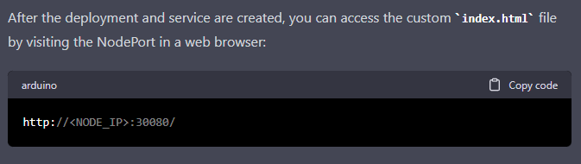

Replace **<NODE_IP>** with the IP address of one of the nodes in your Kubernetes cluster. This should display the custom **index.html** file that you defined in the ConfigMap.

1. Create a WordPress deployment with mysql as a database and expose it to nodeport 30402. Use “volume” namespace for this scenario and login to wordpress with predefined credentials.

Save the yaml file and create the resource by running:

* **kubectl apply -f wordpress.yaml**

1. Create a pod named sidecar with 2 containers named main and sidecar respectively. Fetch the logs from app container to sidecar container. Use nginx for main and busybox:1.28 image for sidecar container

